State FFA Leadership Camp Rising Sun

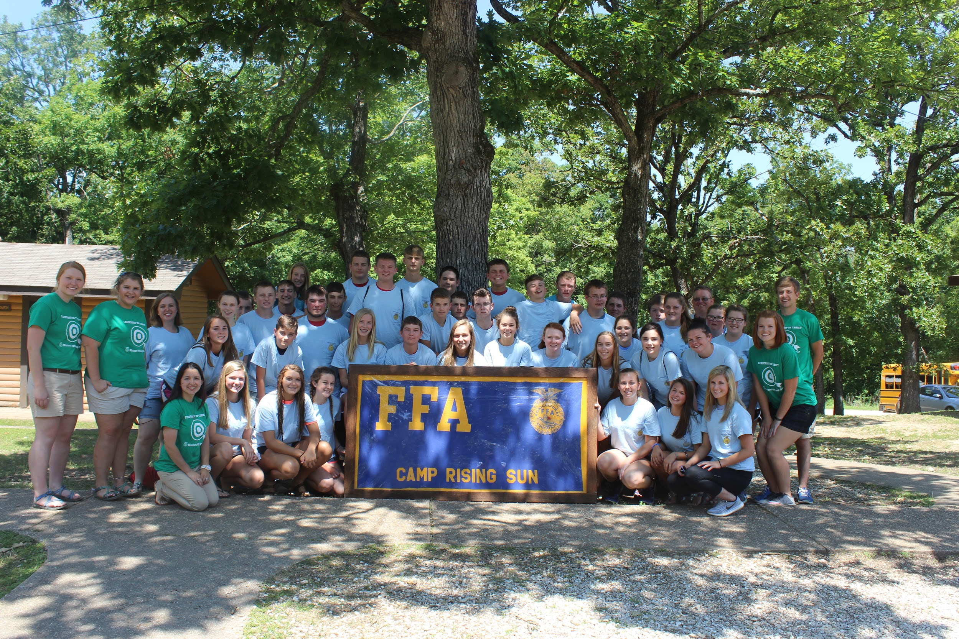
FFA Camp was head in Kaiser, MO. 40 members of the South Shelby FFA Chapter attended the State FFA Leadership Camp from June 26th - July 1, 2017. The Camp sponsored by the Missouri FFA Association was held at camp Rising Sun located within the Lake of the Ozarks State Park. The institute provides leadership training for over 1200 high school students who are members of the FFA across Missouri. The high school students are trained by State FFA officers as well as Leadership Director who is a past State FFA Officer. Students learn how to overcome obstacles and develop their communication and personal skills.
Many of our South Shelby FFA members went through extra leadership training to receive their State FFA Leadership Pin. Members seeking to earn this award must participate in 13 additional leadership activities including contests and elective leadership sessions. FFA members can use the skills built through this training to help them as chapter officers, become stronger/more involved members of their chapter, and help them develop the communication skills which will build connections for their future as well as for the future of agriculture. These members pictured below are: Back Row (left to right): Luke Farrell, Jacob Taylor, Braydon Friesz, and Nellea Dovin. Middle Row (left to right): Rosa Bork, Anna Werr, Anna Carpenter, Elizabeth Fugeat, Caroline Weatherford, Mckenzie Schwieter, Kellie Carothers. Front Row (left to right): Hailey Douglass, Carly Collins, Brennah Collins, and Callie Roetemeyer. Not pictured: Guy Timbrook.

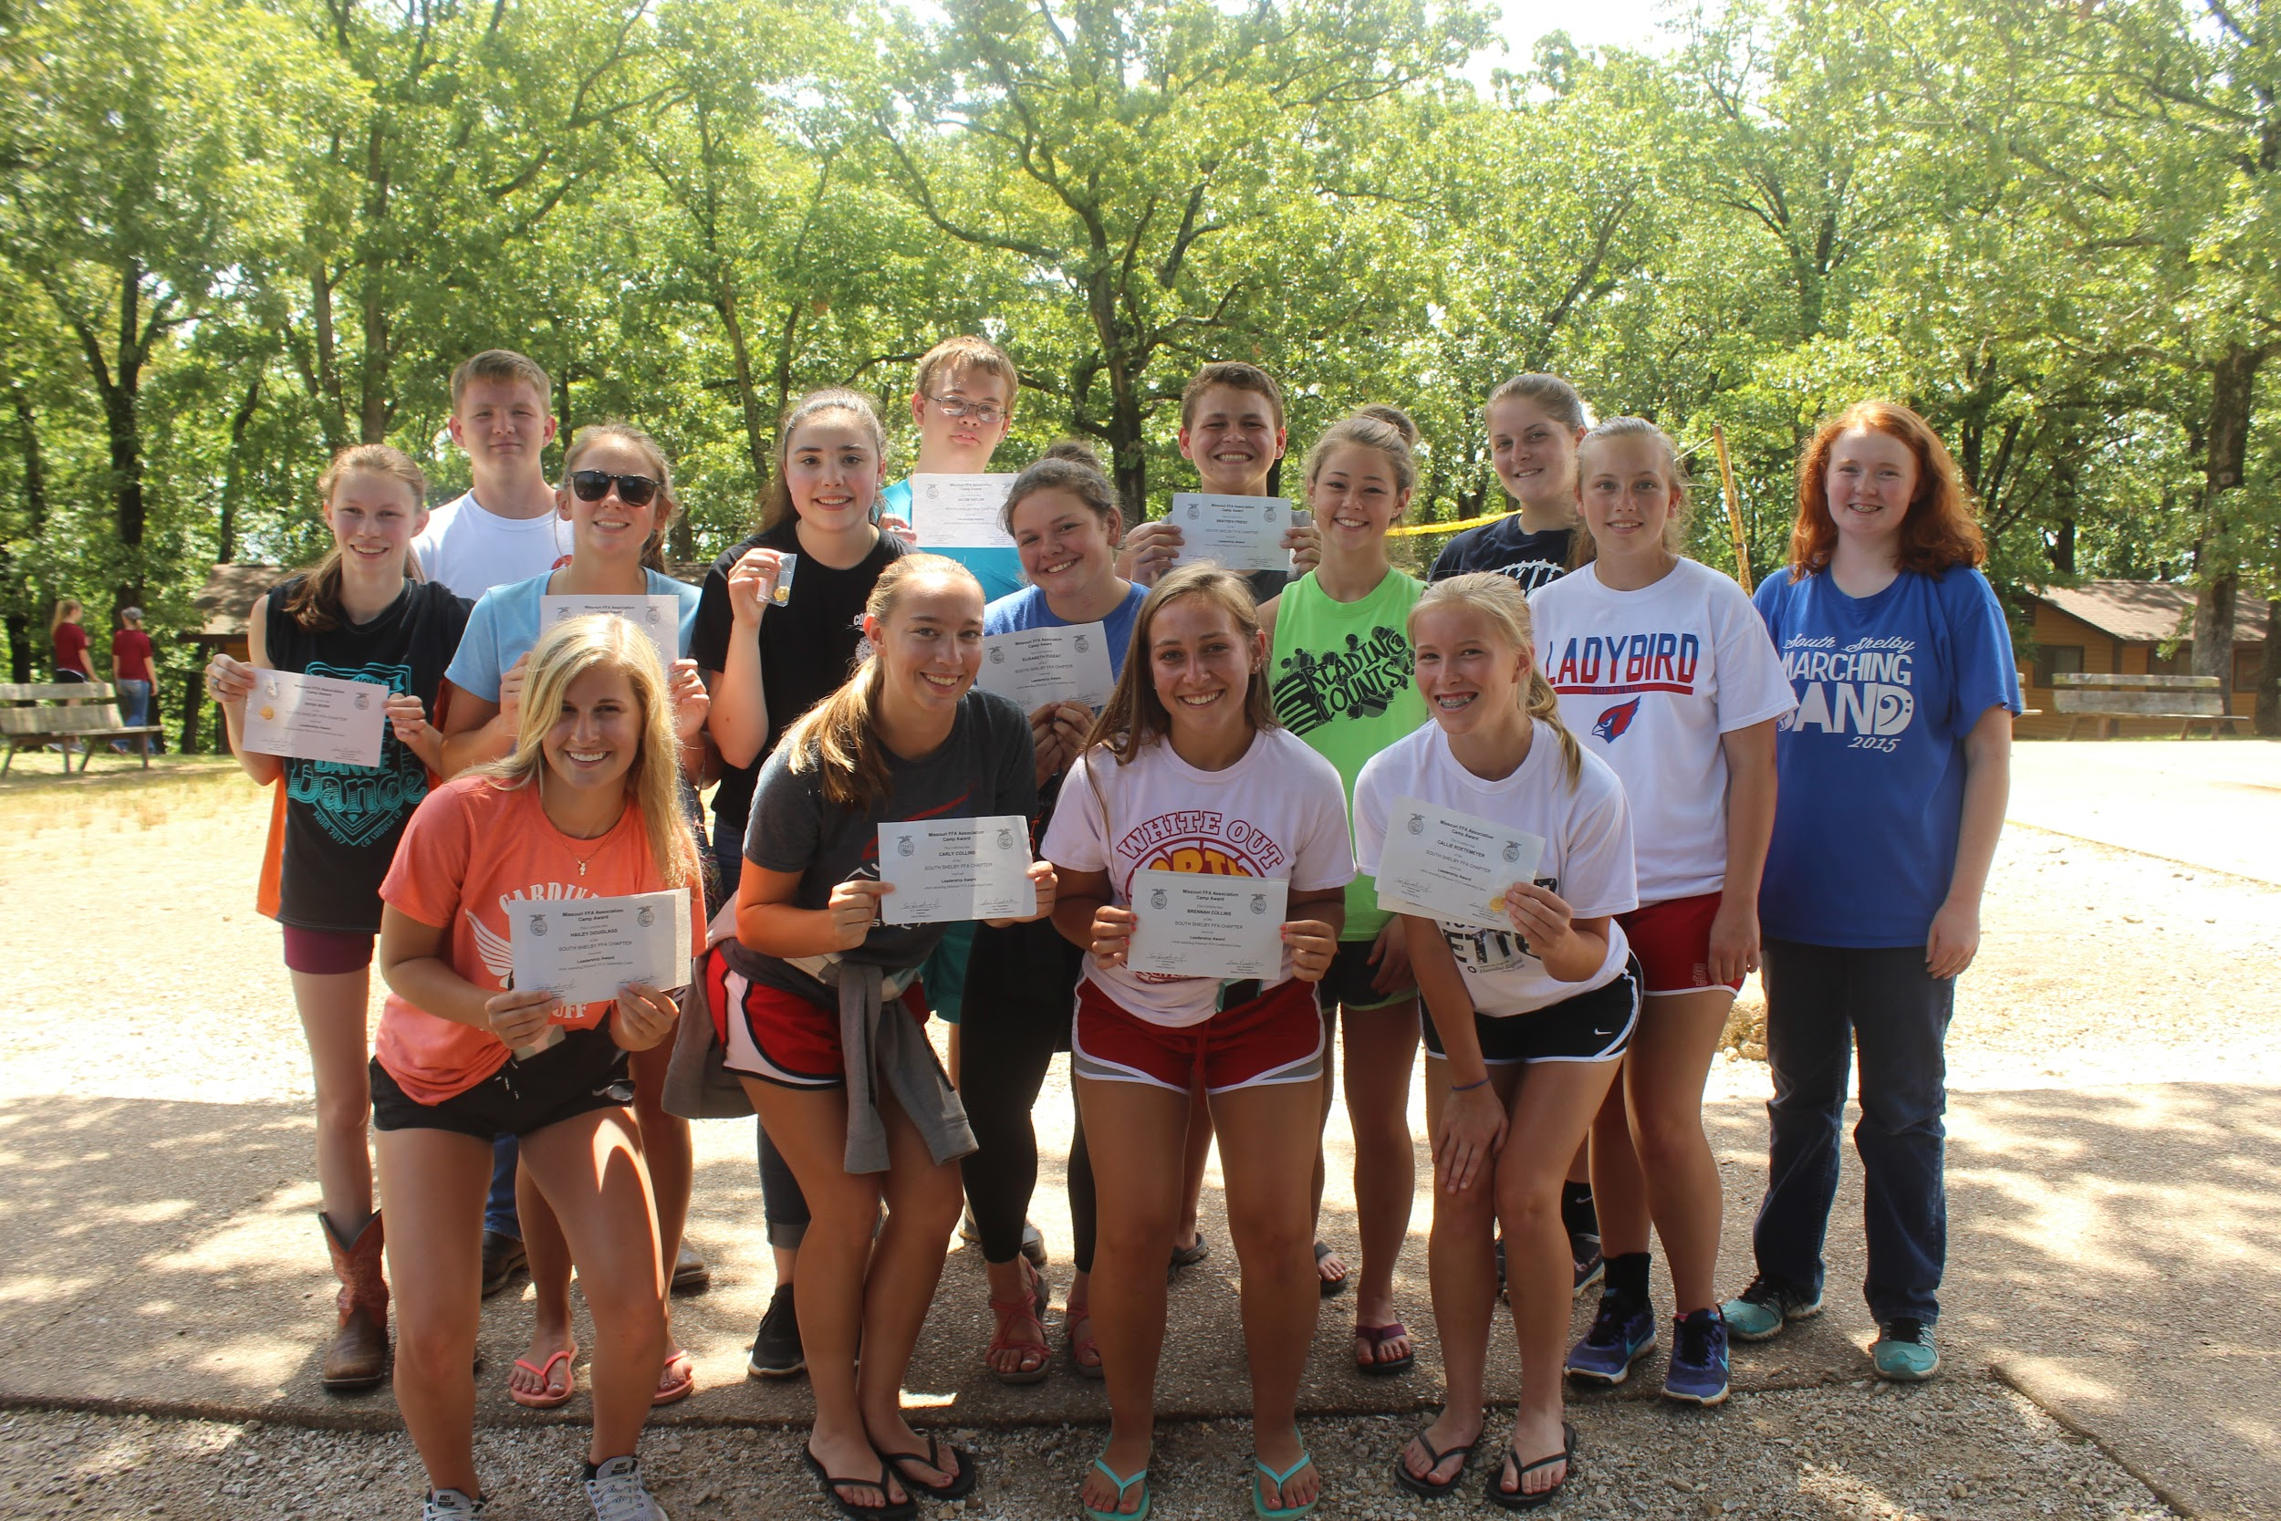
In addition to leadership metals, these students as well their 24 peers attending FFA camp had an extremely fun and successful FFA camp. Highlighting including three South Shelby FFA members tried out for a camp officer position and two of our FFA members received a camp office. Brennah Collins was selected as the 2017 Week Four Secretary and Anna Carpenter became the 2017 Week Four Treasurer. Both officers are pictured below leading a morning eye opener. 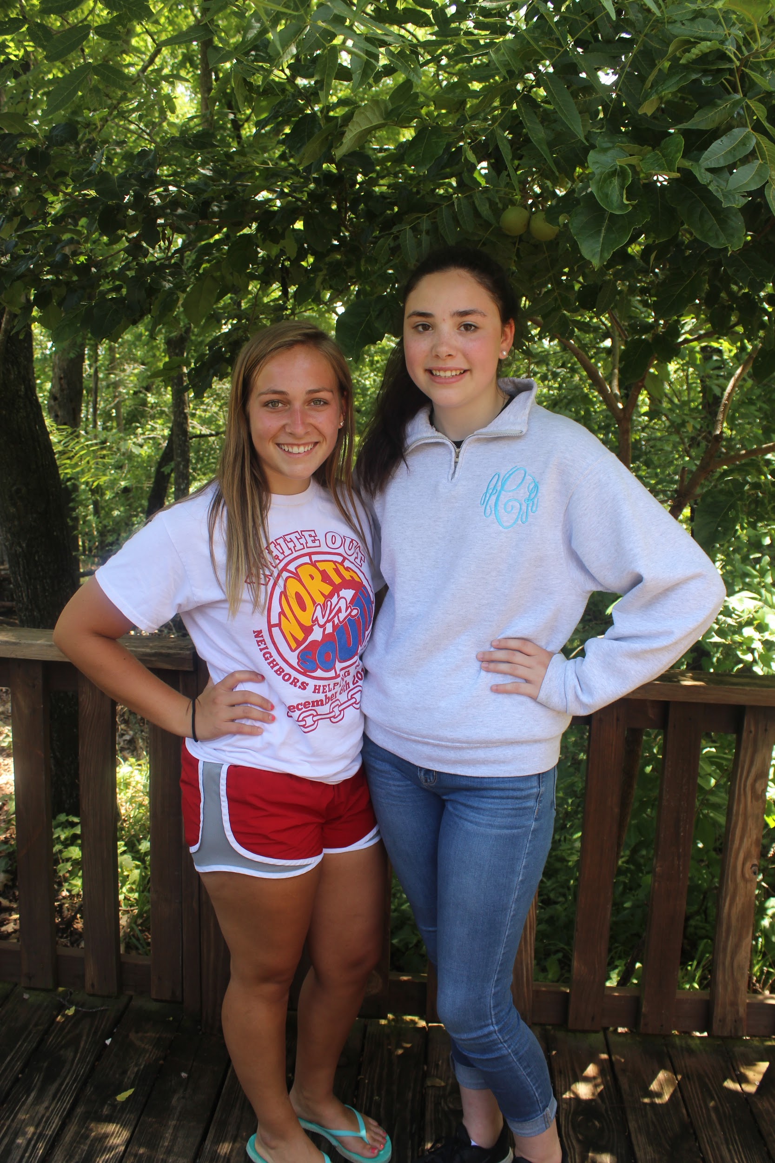
On Monday, every member was given the opportunity to prepare a speech for the Student Lead Look Ahead on Wednesday Evening. One South Shelby FFA member took advantage of this opportunity and shared her inspiration with 190 other campers. Kellie Carothers talked about the Ups and Downs of life and challenged campers to be an “Up” in someone else's life. Kellie is pictured between State Officers Mariah Fox and Elise Bailey who inspired Kellie as she perfected her speech.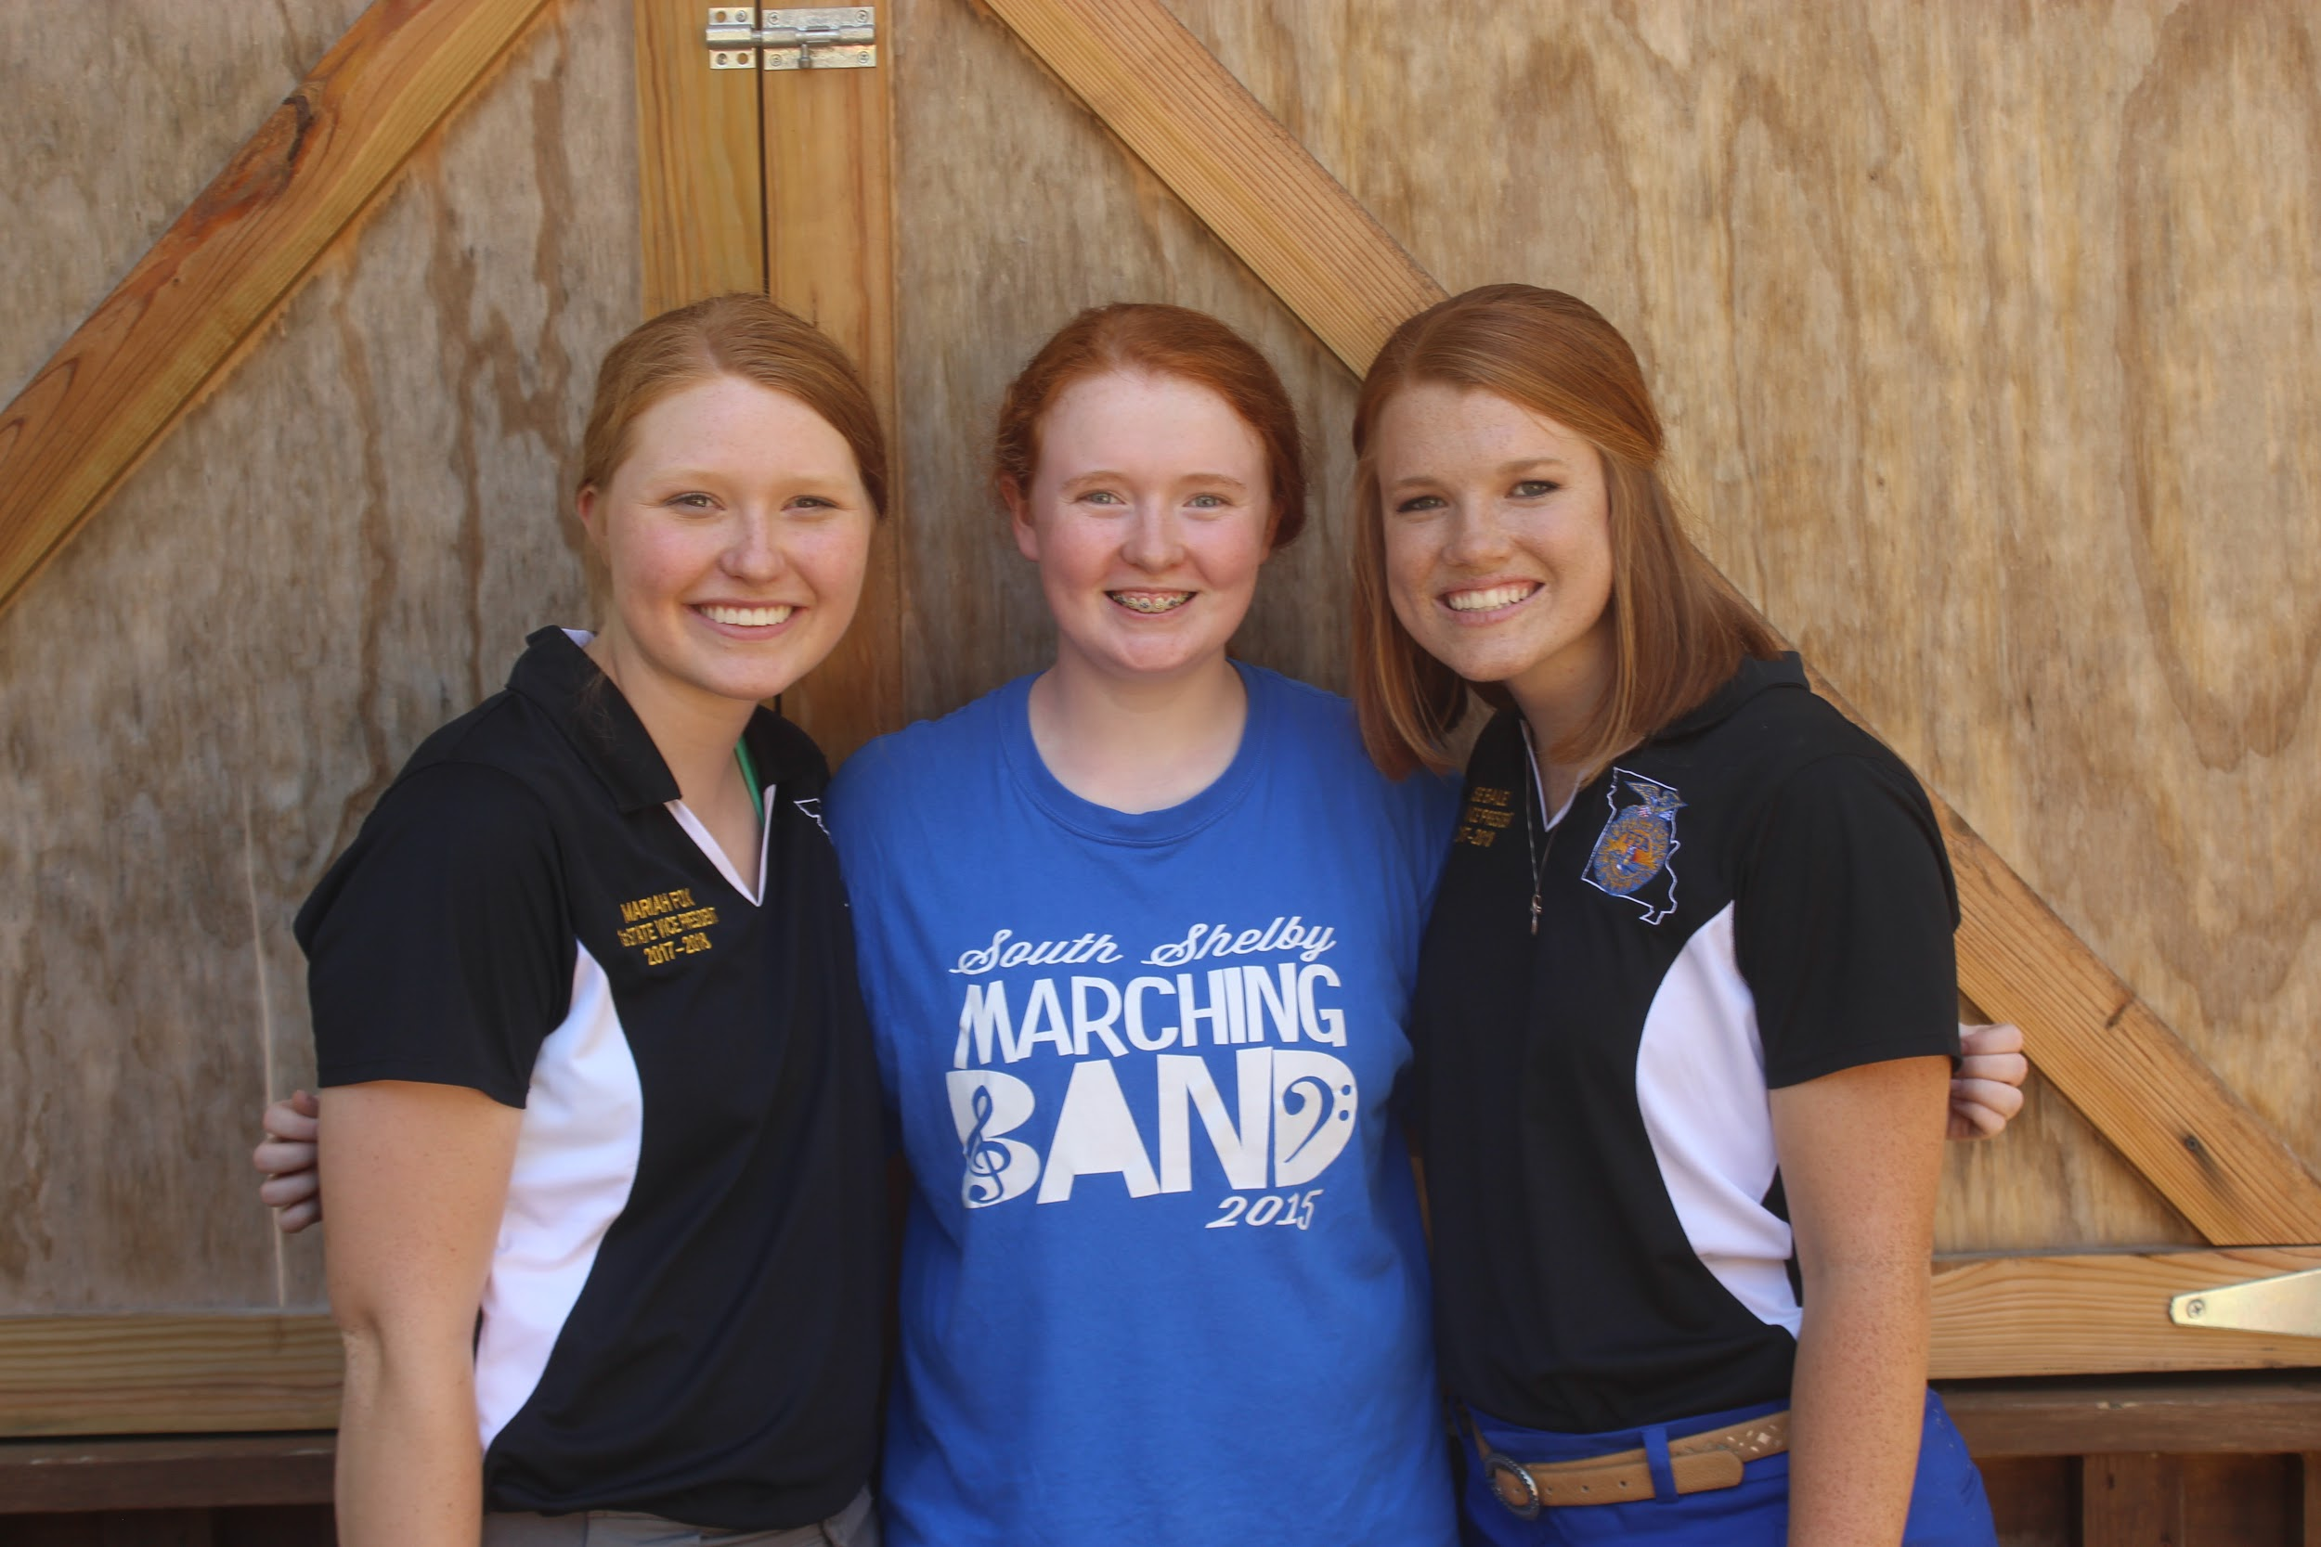
Other highlights include South Shelby FFA placing 2nd in the FFA Rituals Contest. Team members include . Hailey Douglass received 1st Place in the FFA Creed Speaking Contest. 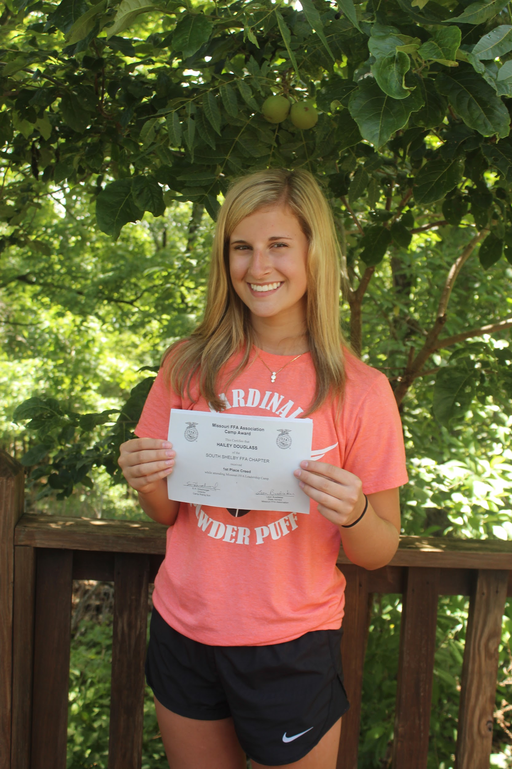Callie Roetemeyer placed 3rd in the Extemporaneous Speaking Contest.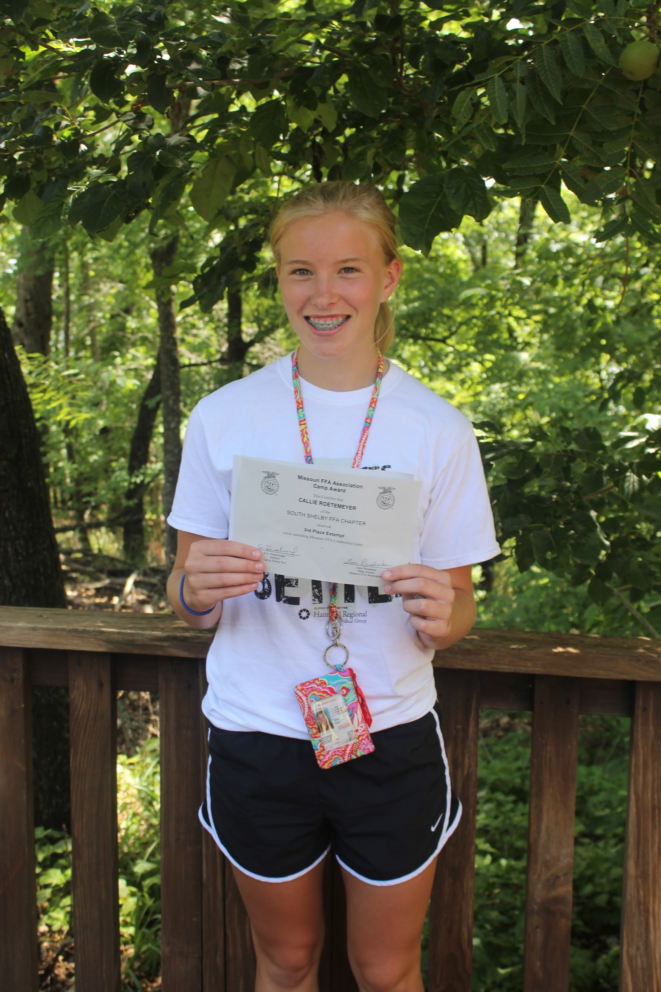 Anna Carpenter tied for 3rd in FFA knowledge.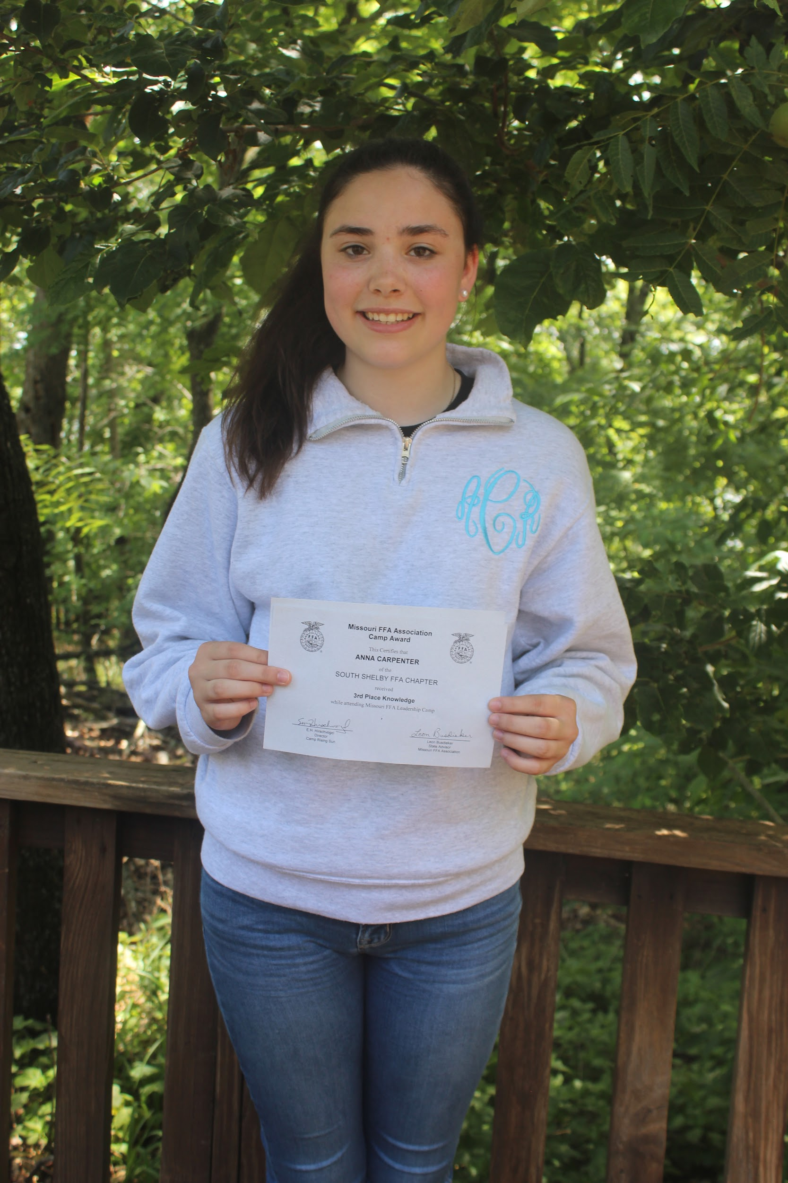
Furthermore, members of the South Shelby FFA chapter also had a chance to test their athletic ability and their teamwork skills through tournament play. Members showed their sportsmanship and their competitiveness throughout several rounds of tournament play. With the support of their teammates and their cheering section, South Shelby FFA teams were Champions of FFA Camp Week Four Volleyball, Softball, and Basketball. Also, for the second year in a row Brock Wood won the Ping Pong Singles and Brock Wood and Lily Wegman brought home the Championship in Ping Pong Doubles.
On Friday morning, the camp holds a waterfront tournament. After two intensive rounds of canoe racing, Cason Wilt and Bud Maubach won second place in the Canoe Race Contest. 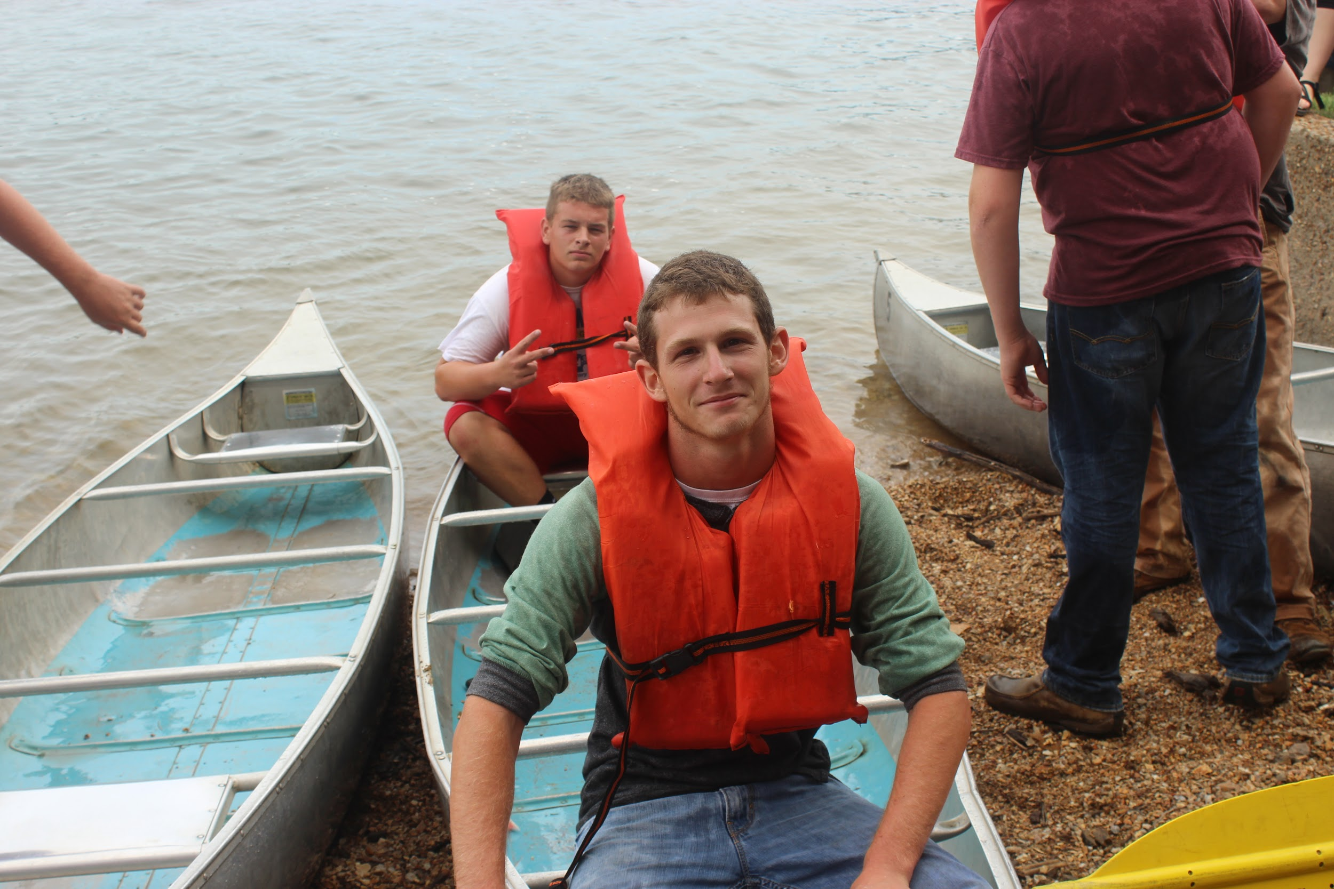The Lifeline Rescue is a contest in which one member pretends to be drowning, a lifeguard throughs them a flotation device with a line attached & swims out to rescue them, while the final member of the team pulls them both back to shore. South Shelby FFA members completing this in the shortest amount of time and therefore becoming waterfront champions were Caroline Weatherford, Daniel Burke (Lifeguard), and Cason Wilt (Puller). 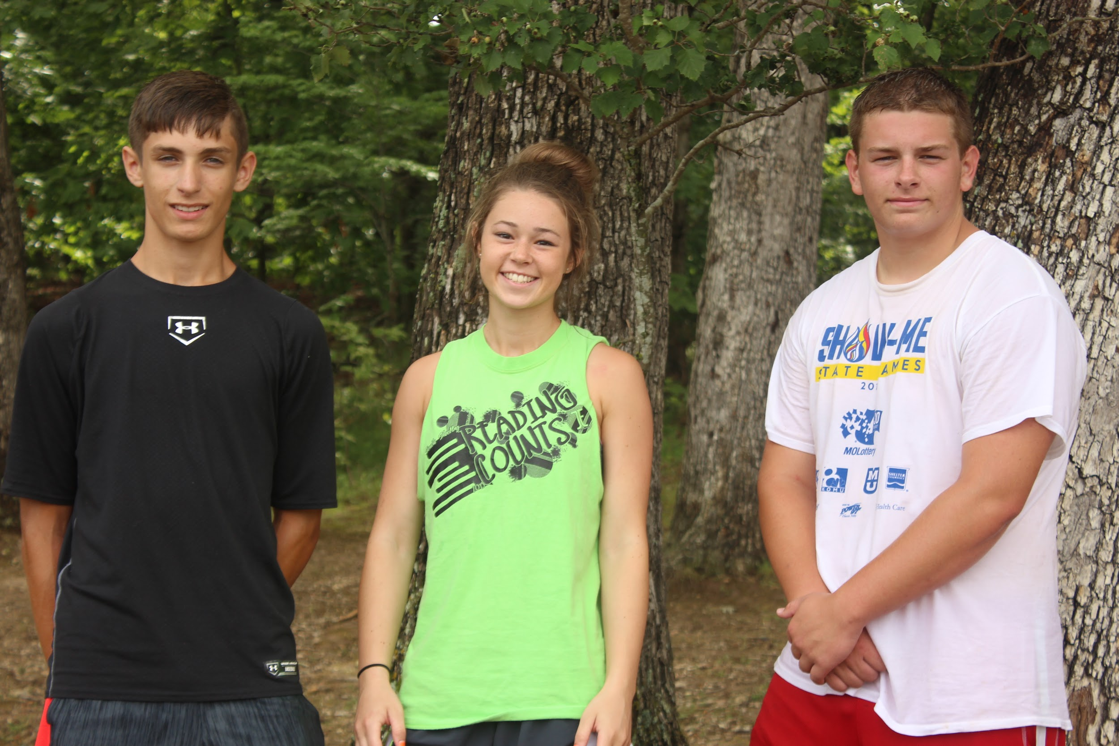
Finally, South Shelby FFA members selected their All Around Camper. This individual received their leadership pin, participated in contests as well as tournaments and played an active role in leadership sessions at camp. Therefore, leading the chapter by example. The 2017 South Shelby All Around Camper is Brennah Collins. Congrats South Shelby FFA members on a fantastic and successful week at 2017 FFA Camp!!!

