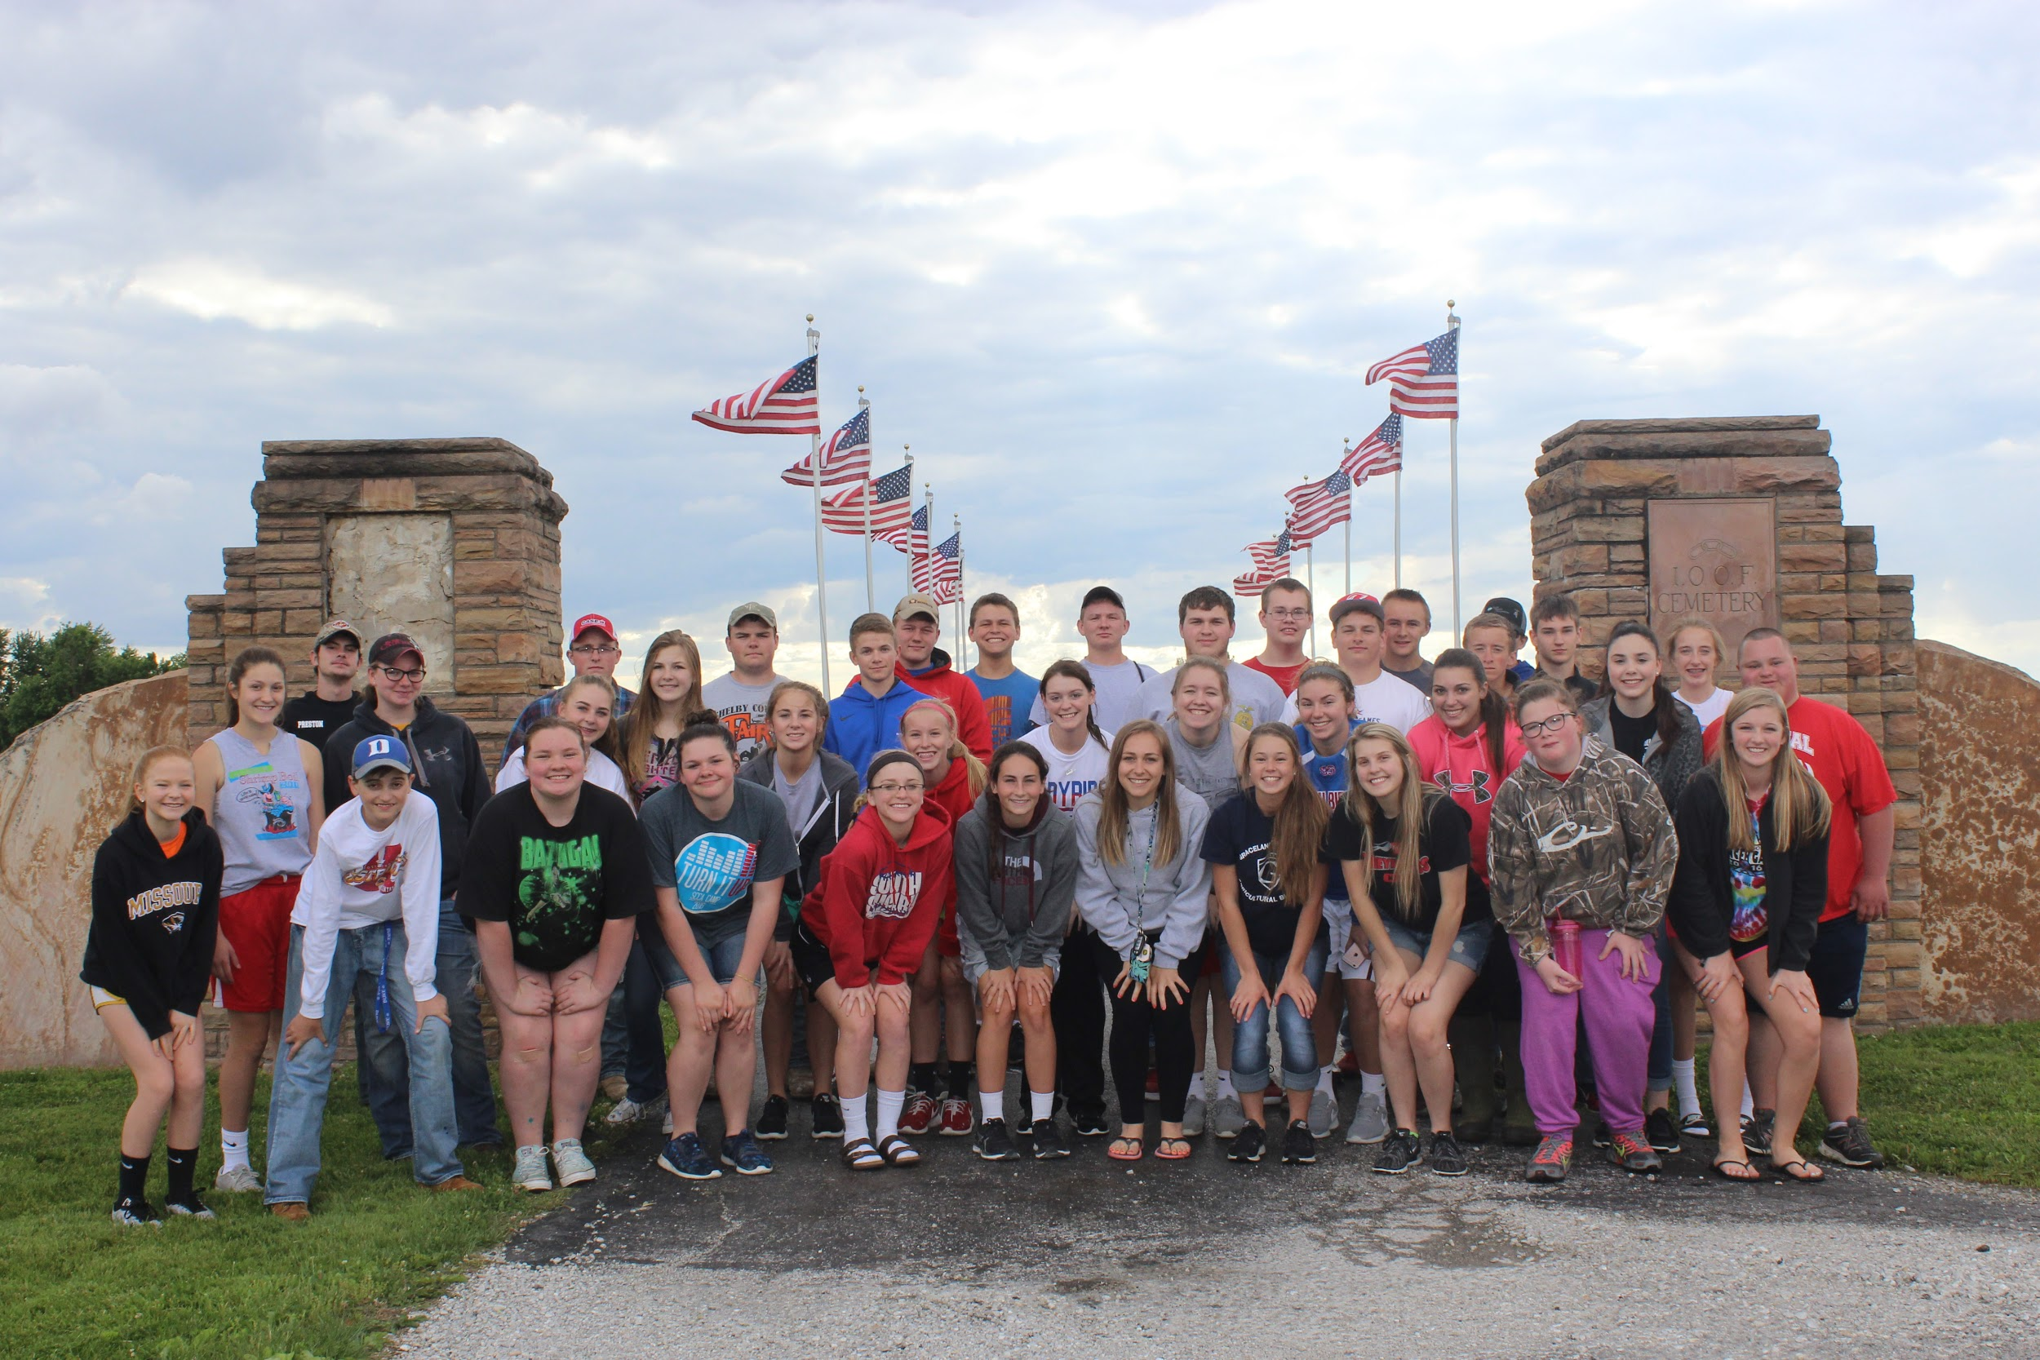

The South Shelby FFA assisted the Teachenor Post 376 American Legion in setting up flags for Memorial Day Weekend. FFA members walked around the Shelbina Cemetery and placed flags next to the graves of veterans to help honor those that served our Country. 39 members attended on Tuesday, May 24th. Members volunteering included Brennah Collins, Luke Farrell, Kim Greenwell, Emilie Hamblen, Caitlin Poore, Miranda Totten, Caroline Weatherford, Drew Wilt, Logan Wise, Anna Carpenter, Brock Fifer, Bryant Fifer, CJ Glover, Colby Harre, Diane Mayes, Katie Mitchell, Austin Schaefer, Sadie Wear, Braden Collins, Amber Durbin, Braydon Friesz, Elizabeth Fugeat, Hadley Hicks, Rebekah Kuntz, Ethan O’Neal, Madison Rash, Callie Roetemeyer, Jacob Taylor, Anna Werr, Cason Wilt, Mallory Wood, Riley Pfannenstiel, Millie Gough, Shawn Wilkerson, Cole Mitchell, Dylan Durbin, Katie Smith, Jenna Hammond, and Kalyn Bales. The South Shelby FFA would like to extend a thank you to all veterans, present and past, for all they do to serve the United States of America.
Written by: Logan Wise, South Shelby FFA Reporter

